Ryan Fleury

5/6/2022

Senior Projects Spring 2022

Read Me

Running the program

To run my python GUI, there are first several python libraries that need to be installed within the IDE of your choice. I used VScode but anyone should work if the libraries are installed. Here is the list of the required libraries:

Library Pip install command

* import praw —--------------------------------------------------------------pip install tk
* import pandas as pd------------------------------------------------------pip install pandas
* from nltk.corpus import words—---------------------------------------pip install nltk
* from sklearn.feature_extraction.text import TfidfVectorizer—--pip install tfidf
* from tkinter import *--------------------------------------------------------pip install tk
* from tkinter import filedialog—------------------------------------------pip install tk
* from textblob import TextBlob-------------------------------------------pip install textblob

Once all of the libraries are installed the file that should be run is called GUI.py. This file will start the program. Here is a screenshot of the execution.

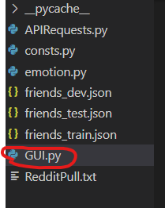

This is the command I use to run the program in VScode. Everything in yellow can be replaced with “python” on a typical system setup.

